EMBEDDED OPERATING SYSTEM:
An OS stored on the rom that manages the devices

MULTICORE PROCESSOR:
Multiple processing units that allow for different instructions to be processed at the same tie.

Little mans computer:
Mnemonics are the STA, ADD, END stuff
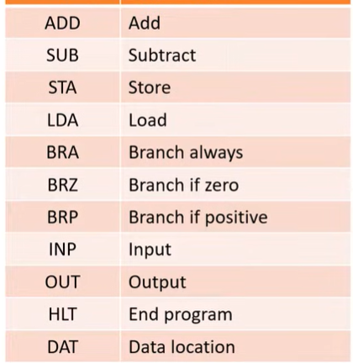

Purpose of a device driver:
Connection between operating system and hardware devices.

